Suggestion: Can there be a way to toggle between portfolios at the head office level for ISO’s that have multiple head offices in either the Vimas or MX Databases.

Today on Vimas, we are able to link an ISO’s Vimas Pro access on one of their portfolios to have access to view a second or third portfolio under their name. Example; Signapay has three codes, 10359, 14793 and 12646 (HR). Main Code 10359 Users are able to toggle back and forth on their 10359 username and view/access merchant accounts under their other codes. This is controlled through the ADTL OFFICE FROMISO # field. This is applicable to any user within Signapay 10359 usernames, just not their sub offices.

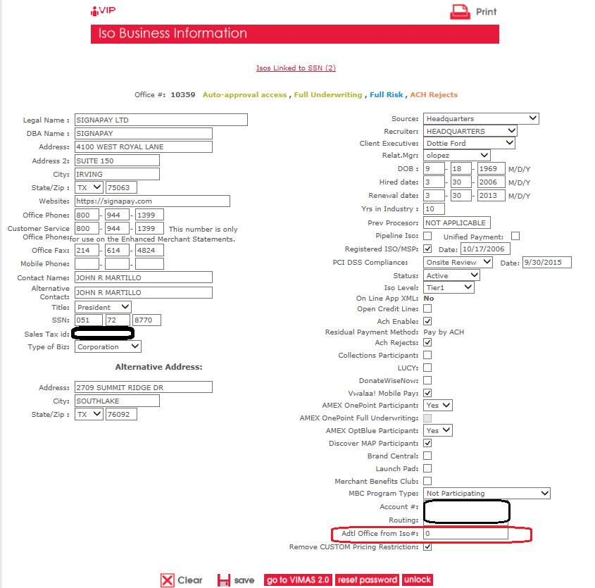

Once they are logged onto their 10359 code, they can click on the CHANGE OFFICE VIEW link on Vimas Pro and switch to a different ISO office without having to log in all over again.

